

# Single Cycle MIPS Processor

Team number: 3

Anas Ahmed Hassan Sayed – 202000005

Ahmed Taha Amin – 18101385

Adel Samir ElZemity – 18101356

Basant Saad Hemida – 19200072

# **Test Case 0**

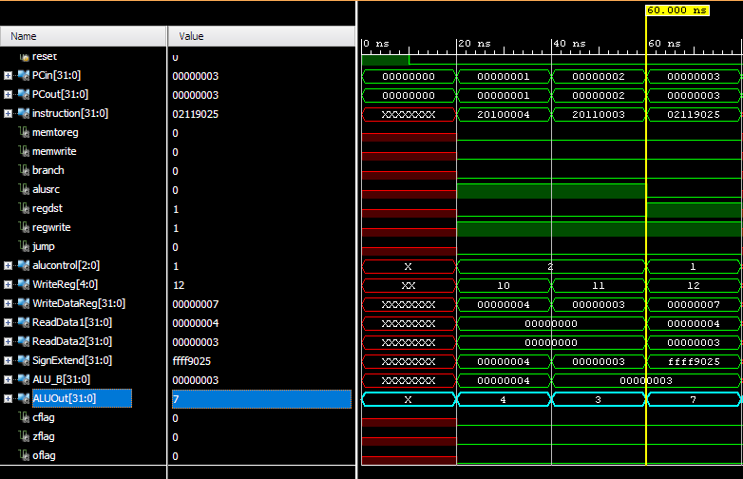

# **Test Case 1**

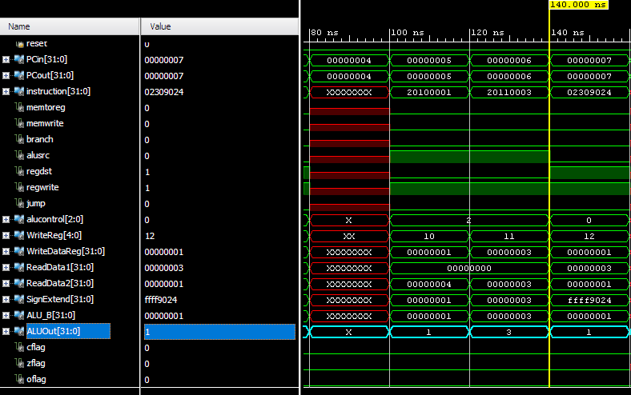

# **Test Case 2**

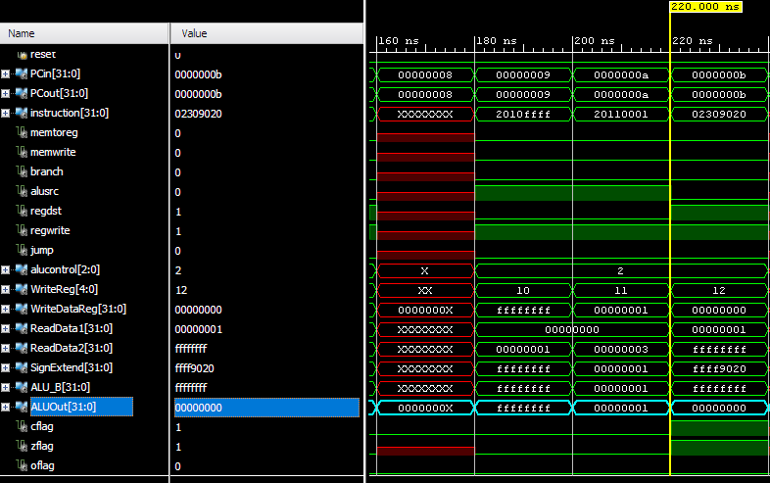

# **Test Case 3**

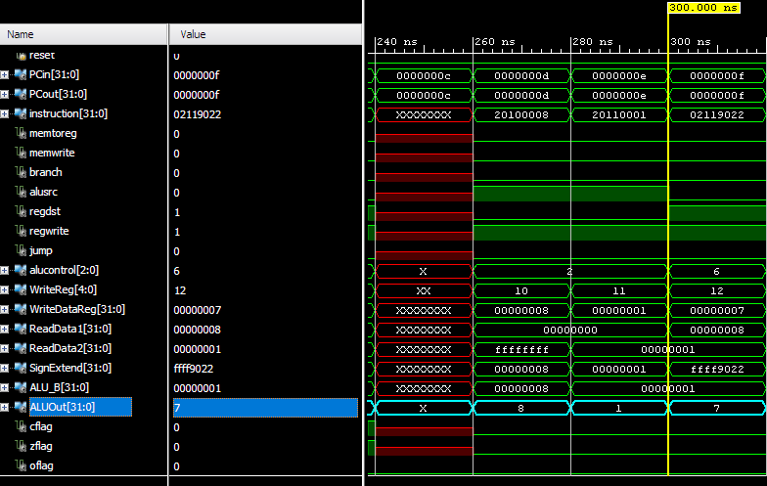

# **Test Case 4**

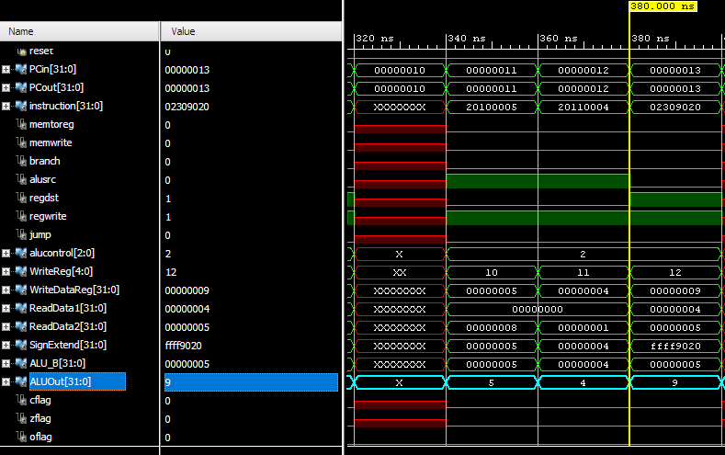

# **Test Case 5**

